Assignment-4

|  |  |
| --- | --- |
| Assignment Date | 25.10.2022 |
| Student name | K.P.JAYAVARSHINI |
| Student Roll Number | 510119104011 |
| Maximum marks | 2 marks |

**Question:-**

Write a code and connections in wokwi for ultrasonic sensor whenever distance is less than 100 cms send alert to ibm cloud and display in device recent events

**program code to connect wowki to ibm cloud:**

#include <wifi.h>

#include<PubSubClient.h>

void callback(char* subscribetopic, byte* payload, unsigned int

payloadLength);

//-------credentials of IBM Accounts------

#define ORG "kotoq5"//IBM ORGANITION ID

#define DEVICE_TYPE "ESP32"//Device type mentioned in ibm watson IOT Platform

#define DEVICE_ID "12345"//Device ID mentioned in ibm watson IOT Platform

#define TOKEN "12345678" //Token

String data3;

char server[] = ORG ".messaging.internetofthings.ibmcloud.com";

char publishTopic[] = "iot-2/evt/Data/fmt/json";

char subscribetopic[] = "iot-2/cmd/test/fmt/String";

char authMethod[] = "use-token-auth";

char token[] = TOKEN;

char clientId[] = "d:" ORG ":" DEVICE_TYPE ":" DEVICE_ID;

WiFiClient wifiClient;

PubSubClient client(server, 1883, callback ,wifiClient);

const int trigPin = 5;

const int echoPin = 18;

#define SOUND_SPEED 0.034

long duration;

float distance;

void setup() {

Serial.begin(115200);

pinMode(trigPin, OUTPUT);

pinMode(echoPin, INPUT);

wificonnect();

mqttconnect();

}

void loop()

{

digitalWrite(trigPin, LOW);

delayMicroseconds(2);

digitalWrite(trigPin, HIGH);

delayMicroseconds(10);

digitalWrite(trigPin, LOW);

duration = pulseIn(echoPin, HIGH);

distance = duration * SOUND_SPEED/2;

Serial.print("Distance (cm): ");

Serial.println(distance);

if(distance<100)

{

Serial.println("ALERT!!");

delay(1000);

PublishData(distance);

delay(1000);

if (!client.loop()) {

mqttconnect();

}

}

delay(1000);

}

void PublishData(float dist) {

mqttconnect();

String payload = "{\"Distance\":";

payload += dist;

payload += ",\"ALERT!!\":""\"Distance less than 100cms\"";

payload += "}";

Serial.print("Sending payload: ");

Serial.println(payload);

if (client.publish(publishTopic, (char*) payload.c_str())) {

Serial.println("Publish ok");

} else {

Serial.println("Publish failed");

}

}

void mqttconnect() {

if (!client.connected()) {

Serial.print("Reconnecting client to ");

Serial.println(server);

while (!!!client.connect(clientId, authMethod, token)) {

Serial.print(".");

delay(500);

}

initManagedDevice();

Serial.println();

}

}

void wificonnect()

{

Serial.println(); Serial.print("Connecting to ");

WiFi.begin("Wokwi-GUEST", "", 6); while (WiFi.status() !=

WL_CONNECTED) { delay(500);

Serial.print(".");

}

Serial.println(""); Serial.println("WiFi

connected"); Serial.println("IP address: ");

Serial.println(WiFi.localIP());

}

void initManagedDevice() {

if (client.subscribe(subscribetopic)) {

Serial.println((subscribetopic)); Serial.println("subscribe to

cmd OK");

} else {

Serial.println("subscribe to cmd FAILED");

}

}

void callback(char* subscribetopic, byte* payload, unsigned int payloadLength)

{

Serial.print("callback invoked for topic: ");

Serial.println(subscribetopic);

for (int i = 0; i < payloadLength; i++) {

//Serial.print((char)payload[i]);

data3 += (char)payload[i];

}

Serial.println("data: "+ data3);

data3="";}

**Diagram.json:**

{

"version": 1,

"author": "sweetysharon",

"editor": "wokwi",

"parts": [

{ "type": "wokwi-esp32-devkit-v1", "id": "esp", "top": -4.67, "left": -114.67, "attrs": {} },

{ "type": "wokwi-hc-sr04", "id": "ultrasonic1", "top": 15.96, "left": 89.17, "attrs": {} }

],

"connections": [

[ "esp:TX0", "$serialMonitor:RX", "", [] ],

[ "esp:RX0", "$serialMonitor:TX", "", [] ],

[

"esp:VIN",

"ultrasonic1:VCC",

"red",

[ "h-37.16", "v-178.79", "h200", "v173.33", "h100.67" ]

],

[ "esp:GND.1", "ultrasonic1:GND", "black", [ "h39.87", "v44.04", "h170" ] ],

[ "esp:D5", "ultrasonic1:TRIG", "green", [ "h54.54", "v85.07", "h130.67" ] ],

[ "esp:D18", "ultrasonic1:ECHO", "green", [ "h77.87", "v80.01", "h110" ] ]

]

}

**program code:-**

#define ECHO_PIN 2

#define TRIG_PIN 3

void setup() { Serial.begin(115200); pinMode(LED_BUILTIN, OUTPUT); pinMode(TRIG_PIN, OUTPUT); pinMode(ECHO_PIN, INPUT);

}

float readDistanceCM() { digitalWrite(TRIG_PIN, LOW); delayMicroseconds(2); digitalWrite(TRIG_PIN, HIGH); delayMicroseconds(10); digitalWrite(TRIG_PIN, LOW);

int duration = pulseIn(ECHO_PIN, HIGH); return duration * 0.034 / 2;

}

void loop() {

float distance = readDistanceCM();

bool isNearby = distance < 100; digitalWrite(LED_BUILTIN, isNearby);

Serial.print("Measured distance: "); Serial.println(readDistanceCM());

delay(100);

}

**circuit daigram:-**

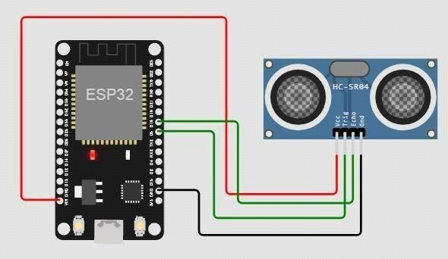

**output:-**

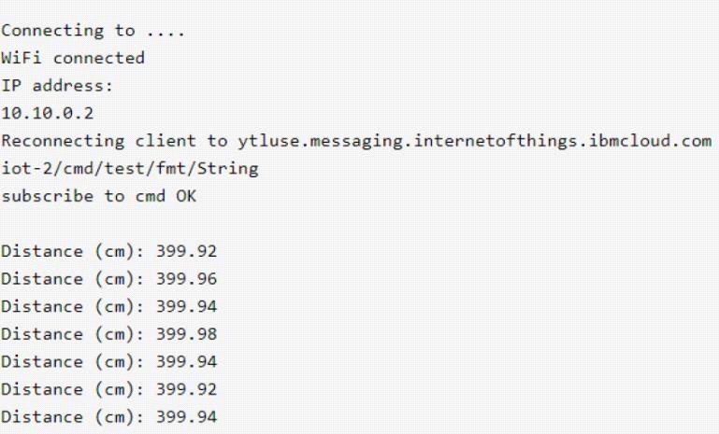

**ibm output:-**

